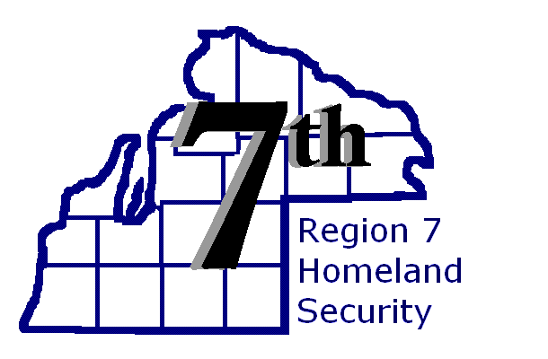

TRAINING ANNOUNCEMENT

ICS-300 Incident Command:
Enhance your Incident Command skills, with a special focus on new concepts of the Incident Command System (ICS). The training and resources provided in this course will assist personnel who require advanced application of the ICS. The course will also benefit any person who has a responsibility to function in a command post managing an expanding incident. You will participate in group activities that introduce the development of the Incident Action Plan (IAP) and demonstrate the interactions between the Command and General Staff sections of the ICS.

Participants:
Participants should come from middle and senior management including:
- Emergency Response Managers
- First-line Supervisors and Administrators Who Will Function as Incident Commanders or Unified Command Staff Members
- Emergency Management Coordinators
- Command and General Staff Members
- Emergency Operations Center Staff Members
- Public Health
- Public Works

Venue:

Cheboygan – Otsego – Presque Isle EDS (COP-EDS)
6065 Learning Center Lane, Indian River, MI 49749

Course Date & Time:

Monday February 21, 2017 1:00 p.m. until 5:00 p.m.
Tuesday & Wednesday February 22nd & 23rd 8:00 a.m. until 5:00.p.m.

Registration:

All participants MUST register in MI TRAIN no later than Friday February 10, 2017.
https://MI.TRAIN.ORG Course ID 1029037 (See attached Instructions).

FEMA / SID Number Required: Students must register and bring a copy of their SID number to class. Register online: https://cdp.dhs.gov/femasid
If You Need Assistance: Contact Megan Anderson Emergency Management Coordinator, (O) 855-515-1624, (E-Mail) manderson@cceoem.net OR Mike Hosh R7HSPB Training & Exercise Planner, (O) 989-619-3381 (E-Mail) hoshmr-7@charter.net

