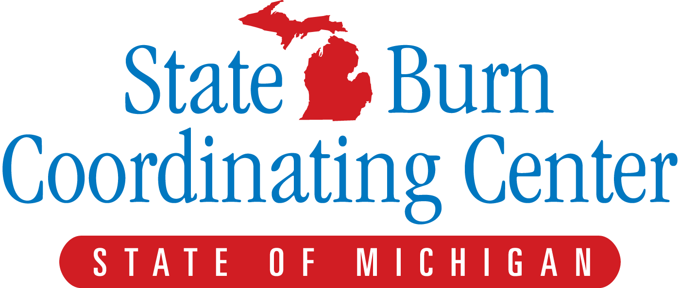
www.michiganburn.org
Disaster events in the United States have a huge impact on economies, families, and communities. Lack of preparedness worsens the devastation. Natural disasters and terrorist events such as the coordinated attacks of September 11, 2001 have highlighted the importance of disaster planning and preparedness. Local healthcare teams are on the front lines of any mass casualty incident and coordinating training is necessary to ensure cohesive local and national responses to disasters.

The University of Michigan, Michigan Department of Community Health, and the Office of Public Health Preparedness have been working together since 2007 on a plan that will coordinate the management of burn patients resulting from a multi-casualty incident. Burn victims make up a large percentage of those injured in terrorist attacks. In the event of a real disaster, providers at all levels throughout the state and region will need to work together to provide the best possible care to victims.

The state of Michigan has 6 burn centers with 79 beds. If a large-scale mass disaster occurs, these centers will be swamped. As burn victims urgently require resuscitation and stabilization, the state’s plan identifies burn surge facilities at key locations that will assist in these patients’ initial treatment until burn center beds become available.

Burn care is unique, requiring a variety of resources and specialized knowledge. To help address this need, the State Burn Coordinating Center team of nurses and physicians has developed a training course to provide Burn Surge Facility (BSF) personnel with burn care education. Today, as a BSF team member, you will be participating in one of these training sessions to acquire the knowledge and hands-on skills needed to treat victims of a burn mass casualty event. And when you return to your workplace, we hope you will pass on all you have learned to other nurses and physicians at your facility. In addition, we hope that you incorporate this plans resources into your own institutions preparedness planning

It is important for you to stay informed and involved. For our statewide plan to be successful, we must all be active, invested members of the team.

Thank you for being here. You are a critical part of the
State of Michigan Burn Mass Casualty Plan

Dear Participant,
Thank you for your interest in being part of the State of Michigan Burn Mass Casualty Plan. We hope to spark your interest and satisfy your curiosity as to what we do and what your part in a disaster situation would be. Your part is very important and we want to make sure you understand what it is that we are asking of you.
The first step in the process is to register for the training session. Included in this packet is the registration form, please fill it out and return it to Anne Fast afast@med.umich.edu as soon as you can. Next you will need to get access to the ABLS – Now site to complete the online portion of the training. Your Regional Medical Coordinator has the access code. Information is included on how to access the site. Once you complete the on-line portion you will receive a certificate stating that you completed that portion. You will need to bring a copy of this to the training day.
The training day consists of lectures in the morning and in the afternoon there will be opportunities to work with our nurses and learn how to apply a dressing to a burn wound, tour the burn unit at the University of Michigan, and access the fluid resuscitation flowsheets and database site on computers set up for this purpose. The afternoon is also when you will be tested on the practical portion of the ABLS certification. The testing consists of a review session and then you will individually be checked off by a qualified ABLS instructor (similar to ACLS, ATCN or TNCC). We follow the American Burn Association guidelines for testing.

Additional information will be provided after the registration form is received.
Anne Fast BSN RN
Training Manager, State Burn Coordinating Center
afast@umich.edu
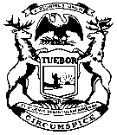
RICK SNYDER  GOVERNOR | State of Michigan  DEPARTMENT OF HEALTH and HUMAN SERVICES  Lansing, Michigan | Nick Lyon  DIRECTOR
Burn Surge Training Course Registration Form
PRE-REQUISITE: ABLS or ABLS NOW
October 7, 2016 St. Ignace, Mi.
Please Type or Print clearly

NAME |  |  |  |  |  | Credentials
Institutional Affiliation
Home Address:
City |  |  | State |  |  |  |  | Zip
Phone Numbers
Home: |  |  | Cell: |  |  |  |  | Work:
E-mail address:
Healthcare Coalition Region you are from?
1 | 2N | 2S |  | 3 | 5 |  | 6 |  |  | 7 | 8
Have you completed the ABLS – Now Online Portion? |  |  |  |  |  |  |  |  |  | Yes | No
Signature |  |  |  |  |  |  |  |  | Date

**Please email completed form to Anne Fast
afast@umich.edu

Bureau of EMS, Trauma and Preparedness 201 Townsend Street Lansing, MI 48913
www.michigan.gov 517-335-8150

