State of Michigan
Burn Mass Casualty Incident: Burn Surge Facility Training

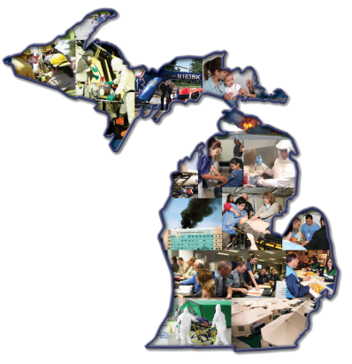

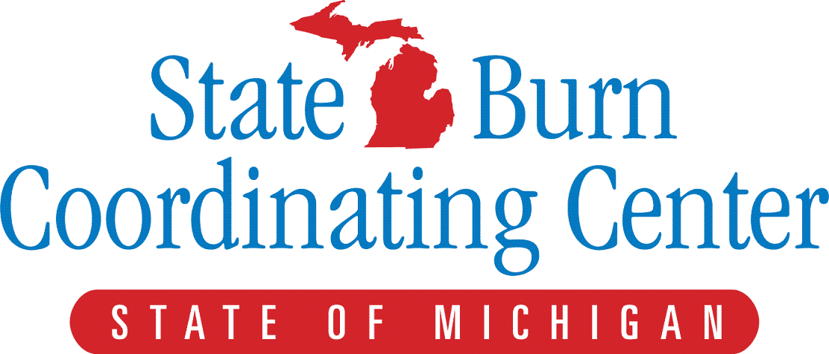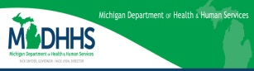

Program Description
Disaster events in the United States have a huge impact on economics, families and communities. Lack of preparedness worsens the devastation. Natural disasters and terrorist events such as the coordinated attacks of September 11, 2001 have highlighted the importance of disaster planning and preparedness. Local healthcare teams are on the front lines of any mass casualty incident and coordinated training is necessary to ensure cohesive local, regional and national responses to disasters.
The University of Michigan Burn Center was designated as the State Burn Coordinating Center (SBCC) and was tasked with the development of a Burn Mass Casualty Incident (BMCI) Plan. Many agencies, including the Michigan Department of Community Health (MDCH) Office of Public Health Preparedness (OPHP) have been working together since 2007 on this plan. Burn victims make up a large percentage of those injured in terrorist attacks. In the event of a real disaster, providers at all levels throughout the state and region will need to work together to provide the best possible care to victims.
The State of Michigan has 6 burn centers with 79 beds. If a large scale mass disaster occurs, these centers will be overwhelmed. As burn victims urgently require resuscitation and stabilization, the state’s plan identifies Burn Surge Facilities (BSF) at key locations that will assist in the initial treatment until burn center beds become available.
Burn care is unique, requiring a variety of resources and specialized knowledge. To help address this need, the SBCC team has developed a training course to provide personnel with burn care education. This training is designed to assist the personnel in acquiring the knowledge and hands-on skills needed to treat victims of a BMCI and to return to your facility and share this knowledge.
It is important for you to stay informed and involved. For our statewide plan to be successful, we must all be active, invested members of the team.
www.michiganburn.org

Who Should Attend:
All healthcare providers, including first responders, who may be required to care for victims of a Mass Casualty Incident will benefit from this training.
Location:
University of Michigan Hospital
1500 E. Medical Center Dr.
Ann Arbor, Michigan
734-936-6238

*List of Hotel accomodations will be provided upon request.

Requirements:
Advanced Burn Life Support on-line course ABLS Now. This is a self-directed, web-based learning program produced by the American Burn Association. The course is designed for first-responders, including firefighters, EMT’s, paramedics, physicians, PA’s, NP’s, nurses and therapists. Additional information will be given upon registration.

Continuing Education Credits:

8 Credits are available to Licensed Paramedics in the State of Michigan
8 Credits are available to Nurses for Michigan Licensure Credits

Registration and Cost:

The cost of the training is provided through the Hospital Preparedness Program through MDHHS. To register for the ABLS training you will be provided a course code by the Healthcare Coalition Regional Medical Coordinator of your region.

Schedule of Day
0730 - 1730
Registration and Sign in
Continental breakfast provided
Introduction to Day
Overview of State Burn Plan
Case Studies
Break
Fluid Resuscitation
Burn Care overview
Lunch Provided
ABLS Practical Practices
Practical Rotations
2 Dressing Stations
Burn Unit Tour
ABLS Practical Testing

Name:
Credentials:
Institutional Affiliation:

Home Address:

City:
State: | Zip:
Healthcare Coalition Region | 1 2N 2S 3 5 6 7 8
Date:

